**23 Sept, 2024 –Monday**

* ACL:
* setfacl – Set file access control list
* It is use to give multiple user access on one file.
* [root@localhost ~]# mount -a acl,remount /
* [root@localhost ~]# setfacl -m u:mayank:rwx p_file.txt
* [root@localhost ~]# setfacl -m u:deepak:r p_file.txt
* To check ACL:
* [root@localhost ~]# getfacl p_file.txt
* To give same ACL to different file:
* [root@localhost ~]# getfacl p_file.txt | setfacl --set-file=- p_file1.txt

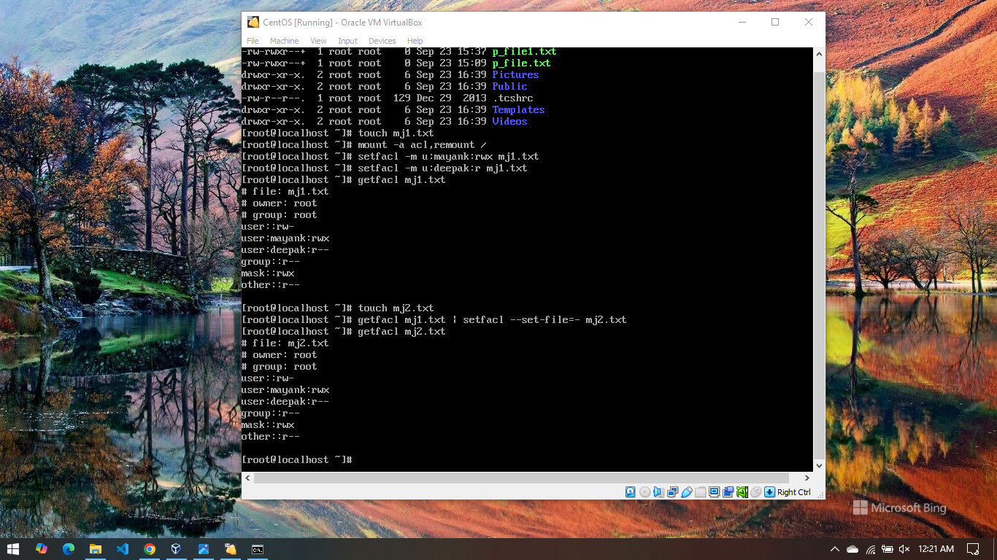

* Mount .iso file, install Apache web server and allow that service using firewall.
* Insert .iso file:
  + Select ‘Machine’ menu of server.
  + Select Storage.
  + Inside Controller iDE select Dropdown near Optical drive
  + Select ‘Choose a disk file’.
  + Select centos .iso file.
  + Ok & Apply

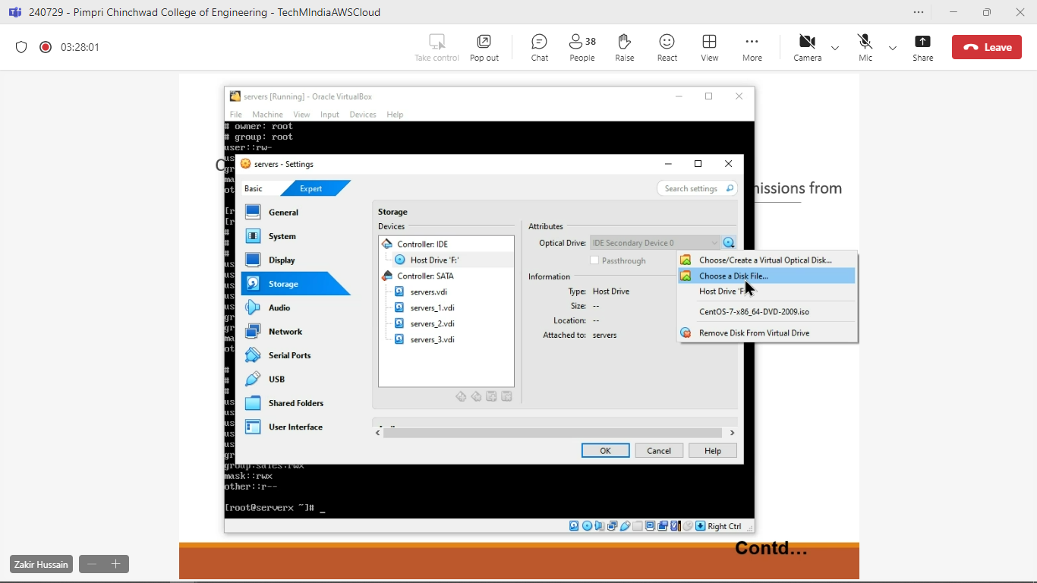

* In CLI of CentOS: [To open: ctl + alt +f2 & close: ctl + alt + f1]
  + To Mount:
    - [root@localhost ~]#mount /dev/sr0 /mnt
    - [root@localhost ~]#ls -l /mnt

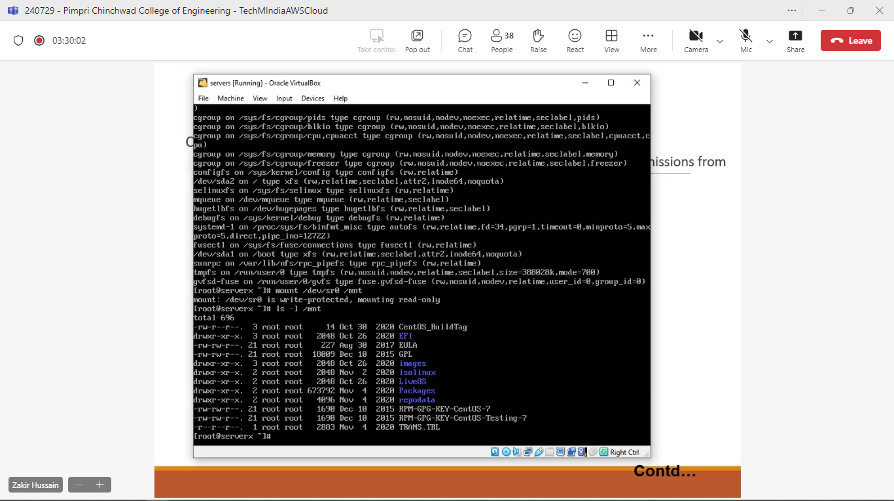

* Open Terminal in CentOS:
  + Application => System Tool => Terminal
    - [root@localhost ~]#cd /etc/yum.repos.d
    - [root@localhost yum.repos.d]#ls –l
* To remove all .repo files:
  + - [root@localhost yum.repos.d]#rm -f *.repo
* Create new repo file:
* [root@localhost yum.repos.d]# vi local.repo
* In VI editor, Press ‘i’ to insert and write the below content:
* [local.repo]

name=centosrepo

baseurl=file:///mnt

enable=1

gpgcheck=1

gpgkey=file://mnt/RPM-GPG-KEY-CentOS-7

* To exit: ESC + :wq
* [root@localhost yum.repos.d]# yum repolist all
* OUTPUT: “enabled:4070”

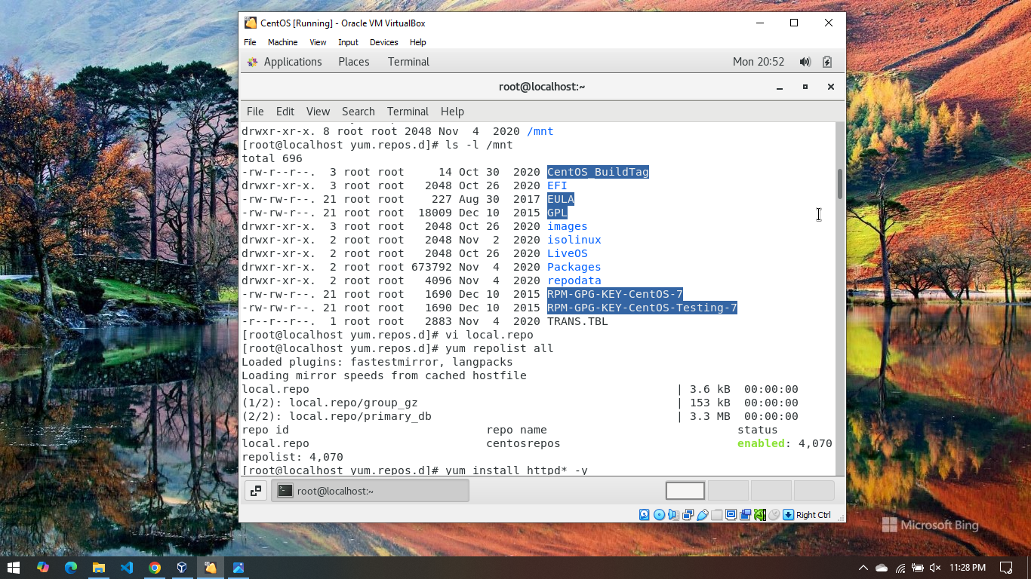

* To install Apache web server:
  + [root@localhost yum.repos.d]# yum install httpd* -y
  + OUTPUT: “Complete!”

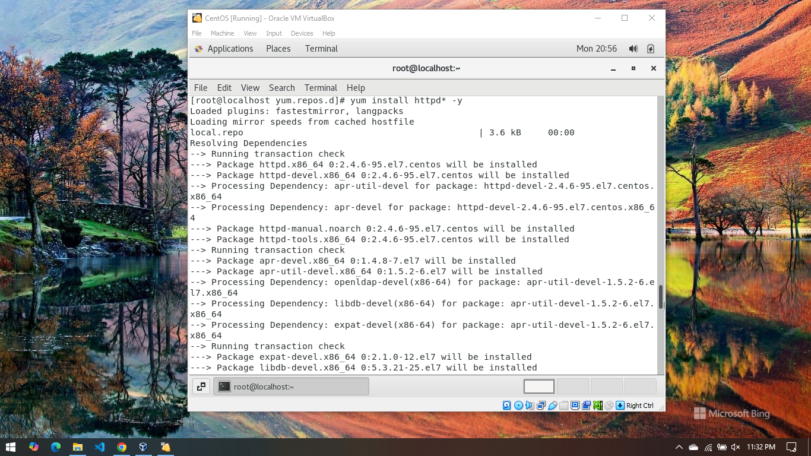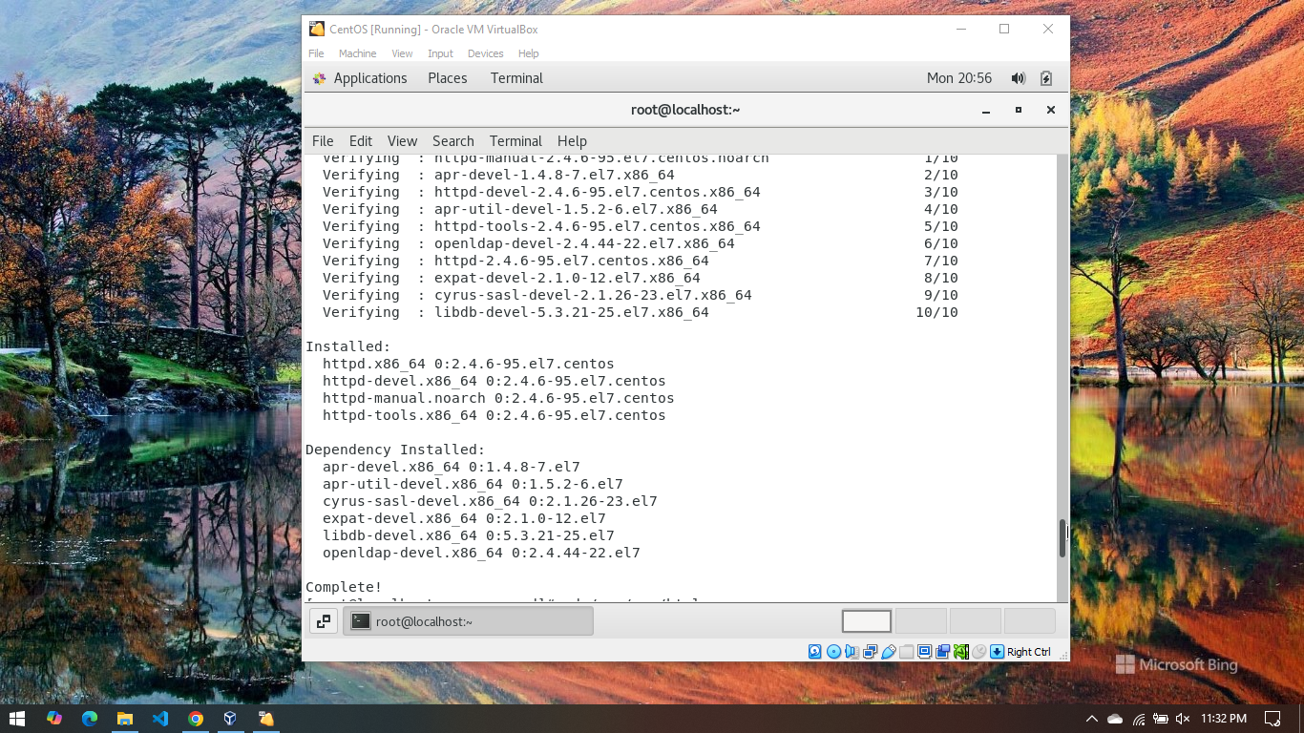

* To confirm it:
  + [root@localhost yum.repos.d]# cd /var/www/html
  + [root@localhost yum.repos.d]# cd ~
  + [root@localhost ~]#
* Allow service by using Firewall:
  + [root@localhost ~]# firewall-cmd -add-service=httpd --zone=public --permanent
  + OUTPUT: “Success”
  + [root@localhost ~]# firewall-cmd --reload
  + OUTPUT: “Success”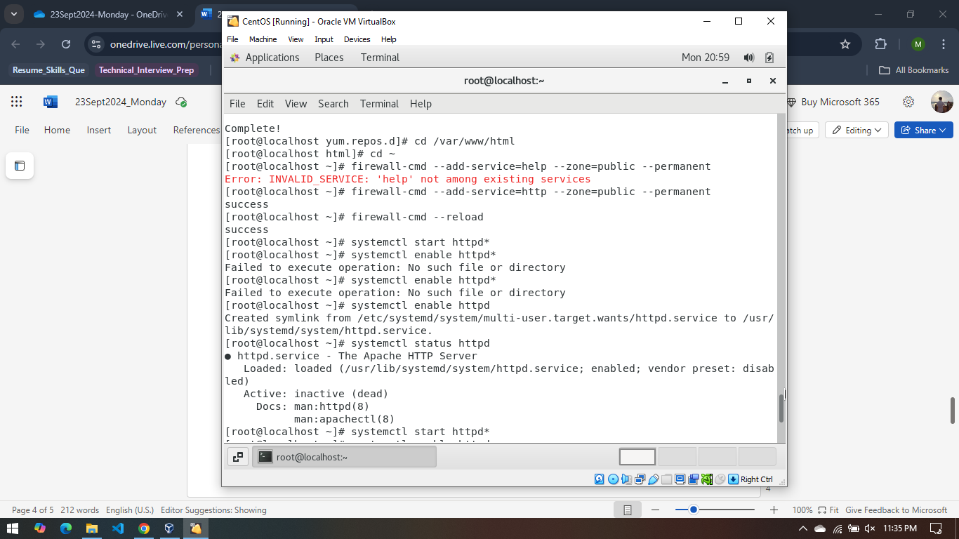
  + [root@localhost ~]# systemctl start httpd
  + [root@localhost ~]# systemctl enable httpd
  + [root@localhost ~]# systemctl status httpd
* Try running last 3 command until you get output like: activate (running)

